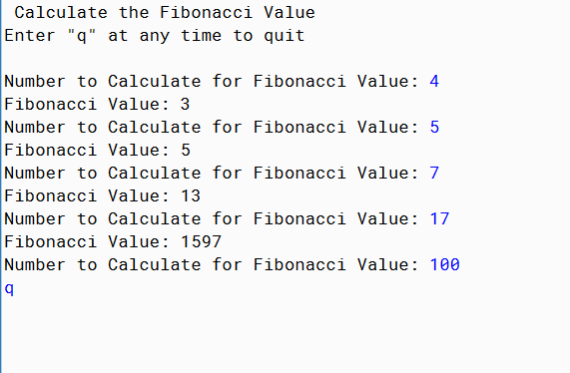

PMR: This program was somewhat simple and a good review. In my opinion the entire lesson about the sss was useless, and I don’t understand totally why so much math was inputted into a lesson for some code. It also didn’t come in much use for this program.

import java.util.Scanner;

/\*

\* Author: Anika Jallipalli

\* Date: 1/12/2020

\*/

public class FibonacciNumbers {

/\*\*

\*

\* @param n is the number that was inputted

\* @return Fibonacci value of number input

\*/

public static int fibonacci(int n) {

if (n == 0) {

return 0;

}

if (n == 1 || n == 2) {

return 1;

}

return fibonacci(n-1) + fibonacci(n-2);

}

/\*\*

\* Run Method

\*/

public static void run() {

System.out.print("Number to Calculate for Fibonacci Value: ");

Scanner in = new Scanner(System.in);

String fiboString = in.next();

if (fiboString.equals("q")) {

System.out.println();

} else {

int fibo = Integer.parseInt(fiboString);

fibo = fibonacci(fibo);

System.out.println("Fibonacci Value: "+ fibo);

run();

}

}

/\*\*

\* Main Method

\* @param args

\*/

public static void main(String[] args) {

System.out.println("Calculate the Fibonacci Value");

System.out.println("Enter \"q\" at any time to quit");

System.out.println();

run();

}

}